EECS332 Digital Image Analysis
MP2 – Mikhail Todes

My coding is done is c++. I complied it in a bash terminal using g++. The code I used to compile and create the executable was “g++ morph_ops.cpp -o morph_ops.e `pkg-config --cflags --libs opencv`”. I then ran the executable from the terminal using ./morph_ops.e.

There are five function in my code.

Mat Dilation (Mat input, int SE);
Mat Erosion (Mat input, int SE);
Mat Opening (Mat input, int SE);
Mat Closing (Mat input, int SE);
Mat Boundary (Mat input);

The Dilation function has a small section inside that checks the number of pixels in a smaller region so that it can filter out noise before the noise is dilated.

The Opening function just calls the Erosion and then Dilation function both with the same structural element. The closing function calls the Dilation and then Erosion function both with the same structural element.

In order to find the boundary, first the image is dilated to create a stronger border line and remove any noise with the small inner function. Then a temporary image is created by eroding the input. The eroded image is then subtracted from the input leaving just the border.

USING gun.bmp AS THE INPUT:
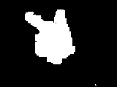Illustration 2: Dilation
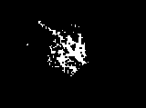Illustration 1: Erosion
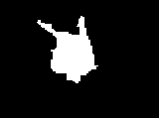Illustration 3: Closing
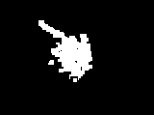Illustration 4: Opening
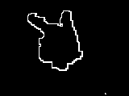Illustration 5: Boundary

USING palm.bmp AS THE INPUT:
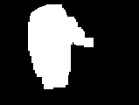Illustration 8: Dilation
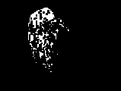Illustration 7: Erosion
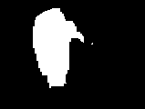Illustration 6: Closing
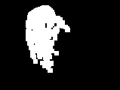Illustration 9: Opening
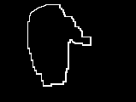Illustration 10: Boundary

